Knowledge Engineering and Data Science – Laboratory Manual
Programme: B.E./B.Tech. (Undergraduate) |
Course: Knowledge Engineering and Data Science | Language: Python 3
Total Experiments: 10 (4 Simple, 4 Medium, 2 Hard) | Total Marks: 100

1. About This Manual
This manual takes students from basic data handling and knowledge representation, through reasoning and ontologies, to evidence-based statistics and hybrid knowledge-and-data systems. Experiments are graded by difficulty so that students build skill step by step, and each one ends with evidence the instructor can check: output, results and a short viva.

1.1 Course outcomes covered
CO | Outcome
CO1 | Represent knowledge using semantic networks, frames, production rules, ontologies and knowledge graphs
CO2 | Build rule-based systems that reason by forward and backward chaining and explain their conclusions
CO3 | Explore, clean, analyse and visualise data with Python
CO4 | Apply inferential statistics (hypothesis tests, ANOVA, chi-square) to draw evidence-based conclusions
CO5 | Acquire knowledge from data using machine learning, and combine it with expert knowledge in a hybrid system

1.2 Experiment overview
No. | Experiment | Level | CO | Bloom level | Duration
1 | Data exploration and cleaning with pandas | Simple | CO3 | K2–K3 | 2 h
2 | Semantic network and inheritance queries | Simple | CO1 | K2–K3 | 2 h
3 | Frames with defaults, inheritance and if-needed procedures | Simple | CO1 | K3 | 2 h
4 | Rule-based system with forward chaining | Simple | CO2 | K3 | 2 h
5 | Backward chaining with a Why/How explanation facility | Medium | CO2 | K3–K4 | 3 h
6 | Building and reasoning over an ontology | Medium | CO1 | K3–K4 | 3 h
7 | Building and querying a knowledge graph | Medium | CO1 | K4 | 3 h
8 | Hypothesis testing, ANOVA and chi-square with evidence | Medium | CO4 | K4 | 3 h
9 | Acquiring rules from data with decision trees | Hard | CO5 | K4–K5 | 4 h
10 | Hybrid decision-support system (knowledge graph, rules and ML) | Hard | CO1, CO2, CO5 | K5–K6 | 6 h

1.3 Software and setup
Item | Requirement
Python | 3.9 or later
Environment | Jupyter Notebook, JupyterLab or VS Code
Libraries | pandas, numpy, matplotlib, scipy, scikit-learn, networkx, rdflib, owlready2
Install command | pip install pandas numpy matplotlib scipy scikit-learn networkx rdflib owlready2
Ontology editor | Protégé (free, from Stanford). A reasoner such as HermiT needs Java installed
Data | Datasets bundled with scikit-learn (Iris, Wine, Breast Cancer), and CSV files given by the instructor or built by students

1.4 Instructions to students
- Predict the result before running code, and note any difference afterwards
- Keep every dataset and program in one folder per experiment
- Do your own work. Copied code that you cannot explain in the viva will lose marks
- Record the library versions used (pip list) so that results can be reproduced

1.5 Record format for every experiment
Aim, tools, algorithm, flowchart, program, input data, output, calculation or analysis, result and inference, and viva answers.

1.6 Marking scheme
Level | Marks per experiment | Split
Simple (4) | 8 | Aim and algorithm 2, program 3, output and result 2, viva 1
Medium (4) | 10 | Aim and algorithm 2, program 3, output and analysis 3, viva 2
Hard (2) | 14 | Design 3, program 4, evaluation and evidence 4, report 1, viva 2
Total | 100 | 4 × 8 + 4 × 10 + 2 × 14

PART A – SIMPLE EXPERIMENTS

Experiment 1: Data Exploration and Cleaning with pandas
Level: Simple | CO: CO3 | Duration: 2 hours | Marks: 8
Aim: To load a dataset, inspect it, handle missing and inconsistent values, and summarise it using descriptive statistics and charts.
Tools: Python, pandas, matplotlib
Dataset: student_marks.csv supplied by the instructor, with columns reg_no, department, gender, attendance, internal, final_exam, study_hours. Include a few blank cells, one repeated row and an impossible value (for example attendance of 140), so there is something to clean.
Procedure:
- Load the file with pd.read_csv and display head(), shape, info() and describe()
- Count missing values for each column with isna().sum()
- Fill missing numbers with the median and missing categories with the mode. State why the median was chosen
- Remove duplicate rows and correct or drop impossible values
- Compute the mean, median, standard deviation, minimum and maximum of final_exam. Group by department and compare the means
- Draw a histogram of final_exam, a box plot by department and a scatter plot of study_hours against final_exam
- Compute the correlation between study_hours and final_exam
Expected output: A cleaned dataset (saved as student_marks_clean.csv), a table of summary statistics and three labelled charts.
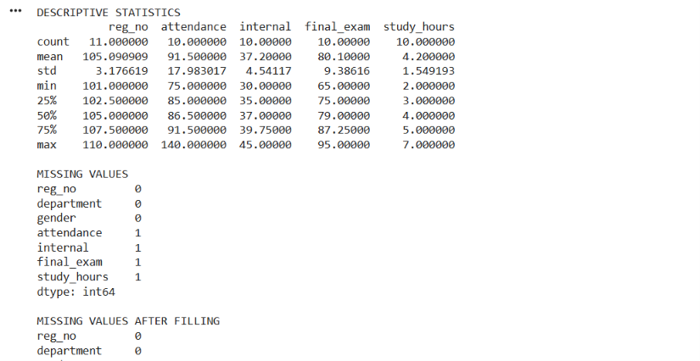
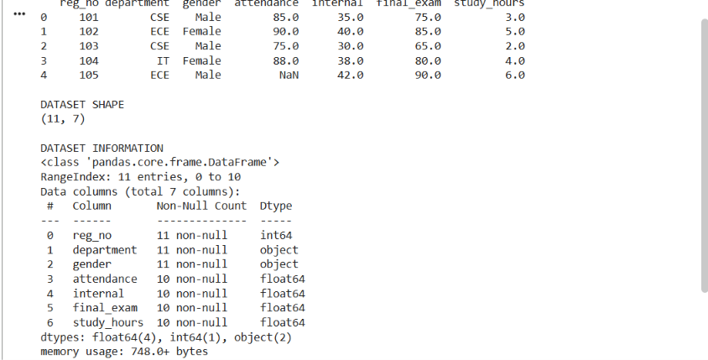

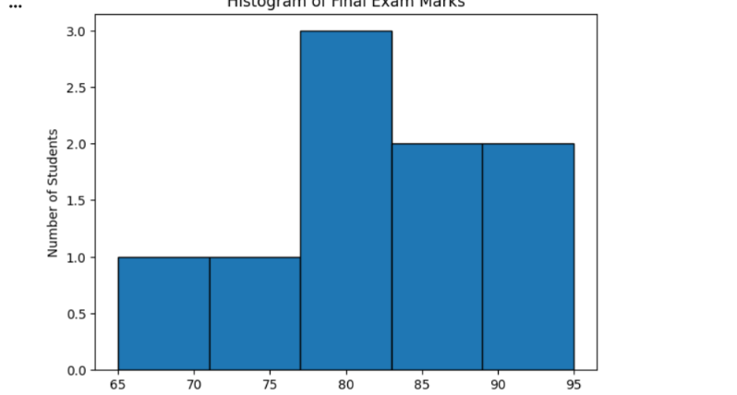
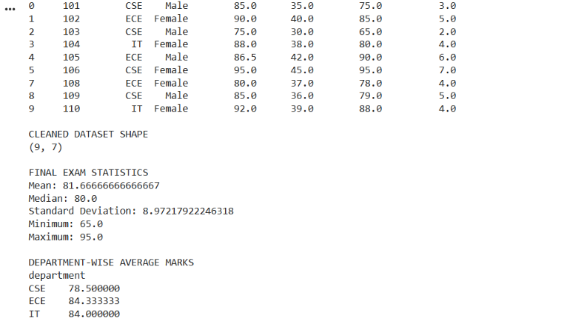

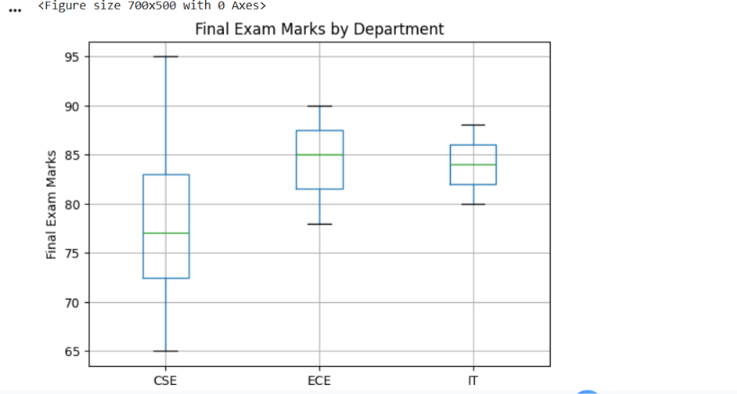

Viva questions:
- Why is the median better than the mean for filling missing values when there are outliers?
- What does a correlation of 0.7 tell you, and what does it not tell you?
- How did cleaning change the mean of final_exam?

Experiment 2: Semantic Network and Inheritance Queries
Level: Simple | CO: CO1 | Duration: 2 hours | Marks: 8
Aim: To represent a domain as a semantic network and to answer questions by inheritance and path search.
Tools: Python, networkx, matplotlib
Domain: Animals (Animal, Bird, Fish, Canary, Penguin, Tweety) or a domain of your own, such as vehicles or university staff.
Procedure:
- Create a directed graph with networkx.DiGraph. Add nodes for classes and individuals
- Add edges with a relation attribute: is-a, instance-of, has-part, can, colour
- Draw the network with labelled edges
- Write a function inherits(node, relation) that looks at the node, then follows is-a and instance-of links upward until it finds the relation, and returns the most specific value
- Test with: Can Tweety fly? Does Tweety have wings? Can a penguin fly? (add a cannot fly value at Penguin to test overriding)
- Write a function that finds the path between two concepts (for example Tweety and Animal) using nx.shortest_path
- Expected output: A drawing of the network, answers to at least five queries with the path of links followed, and a note on how the exception was handled.
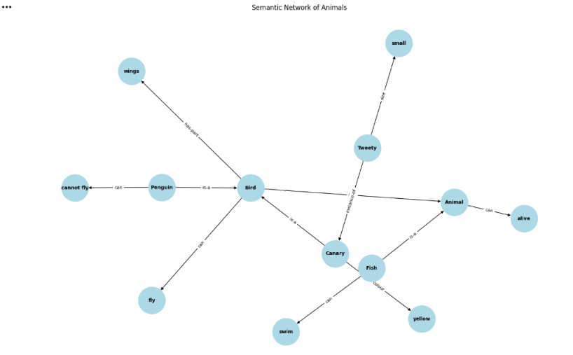
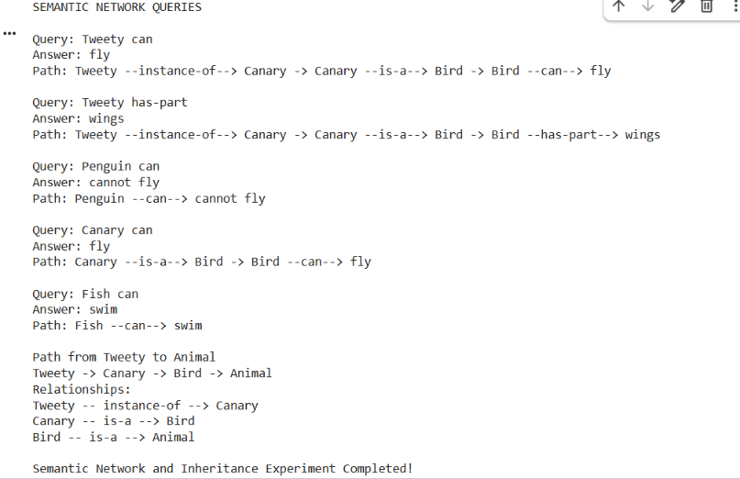

Viva questions:
- What is inheritance and why does it save storage?
- How does your function decide between an inherited value and a local one?
- What can a semantic network not express easily?

Experiment 3: Frames with Defaults, Inheritance and If-Needed Procedures
Level: Simple | CO: CO1 | Duration: 2 hours | Marks: 8
Aim: To implement frames in Python with slots, default values, inheritance and attached procedures.
Tools: Python (classes and dictionaries)
Domain: Vehicle, Car, MyCar (or Student, UGStudent, an individual student).
Procedure:
- Implement a Frame class holding a name, an optional parent, and a dictionary of slots. Each slot stores a value, a default and optionally an if_needed function
- Write get(slot) so that it checks, in order: the frame's own value; its if-needed procedure; its default; then the parent frame
- Write set(slot, value) that runs an optional if_added procedure (a "demon"), for example one that prints a warning when mileage is set below zero
- Build the hierarchy Vehicle, Car and MyCar. Give Vehicle wheels = 4 as default and a mileage slot computed by an if-needed function from odometer and fuel_used
- Print the value of each slot for MyCar and say whether it came from the frame, a default, a procedure or a parent
Expected output: A working frame class, a printed table of slot values with the source of each, and a demonstration of one demon firing.
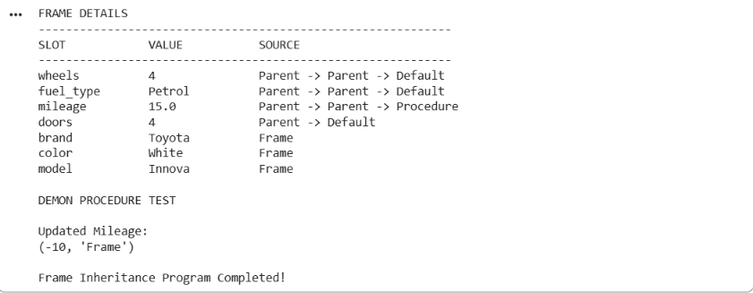

Viva questions:
- How are frames similar to classes in object-oriented programming, and how do they differ?
- What is the purpose of a default value?
- When would you use an if-needed procedure instead of storing a value?

Experiment 4: Rule-Based System with Forward Chaining
Level: Simple | CO: CO2 | Duration: 2 hours | Marks: 8
Aim: To build a small production system that applies IF-THEN rules to a set of facts by forward chaining.
Tools: Python
Domain: Loan eligibility, crop advice or laptop fault diagnosis. Use at least eight rules.
Procedure:
- Store each rule as a pair: a set of conditions and a conclusion, for example ({"income_ok", "credit_good"}, "approve")
- Store the starting facts in a set (working memory)
- Write the recognise-act cycle: find all rules whose conditions are all in the facts and whose conclusion is not already there; pick one (first match); add its conclusion; repeat until nothing new can be added
- Print each cycle: which rules matched (the conflict set), which fired, and the current facts
- Test with three different sets of starting facts, including one that leads to no conclusion
- Add a second conflict resolution strategy (most specific rule first) and compare the order of firing
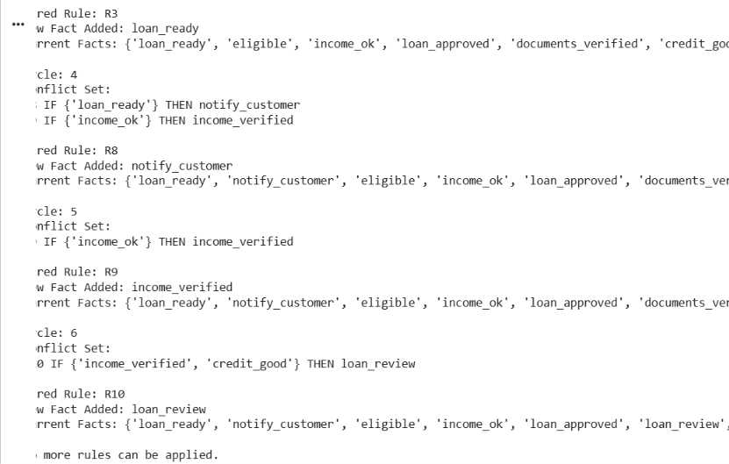
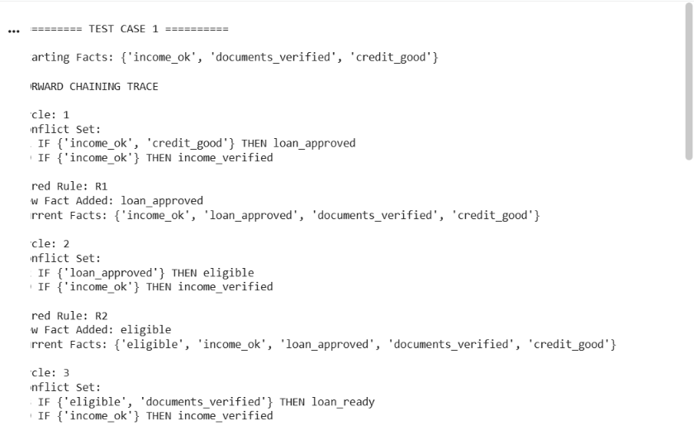
- Expected output: A trace table with one row per cycle, and the final conclusions for each test.

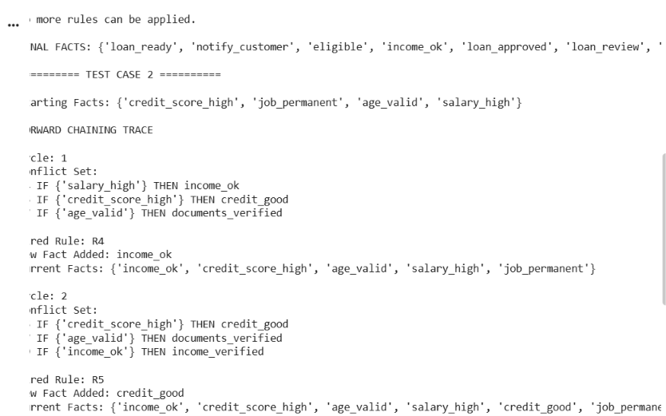

Viva questions:
- What is a conflict set and how did you resolve conflicts?
- Why does the loop stop?
- How does forward chaining differ from backward chaining?

PART B – MEDIUM EXPERIMENTS

Experiment 5: Backward Chaining with a Why/How Explanation Facility
Level: Medium | CO: CO2 | Duration: 3 hours | Marks: 10
Aim: To implement goal-driven reasoning that asks the user for missing facts and can explain why it asks and how it reached a conclusion.
Tools: Python
Domain: Diagnosis of a plant disease, a network fault or a medical triage assistant (educational use only). Use at least 12 rules and 3 or more possible conclusions.
Procedure:
- Represent rules as rule_id, [conditions], conclusion. Keep facts in a dictionary of fact: True/False
- Write a recursive function prove(goal): if the goal is a known fact, return it; if there are rules concluding the goal, try each by proving all its conditions; if the goal is askable (a basic observation), ask the user yes or no and store the answer
- Keep a proof trace (the rules used and the facts asked)
- Add the Why facility: when the system asks a question, the user can type why to see the rule and goal that required the question
- Add the How facility: after a conclusion, print the chain of rules and facts that proved it
- Run at least four consultations covering different conclusions and one that proves nothing
Expected output: Recorded consultations with Why and How outputs, and a short comparison of the number of questions asked by backward chaining versus the number of rules checked by forward chaining on the same rule base.
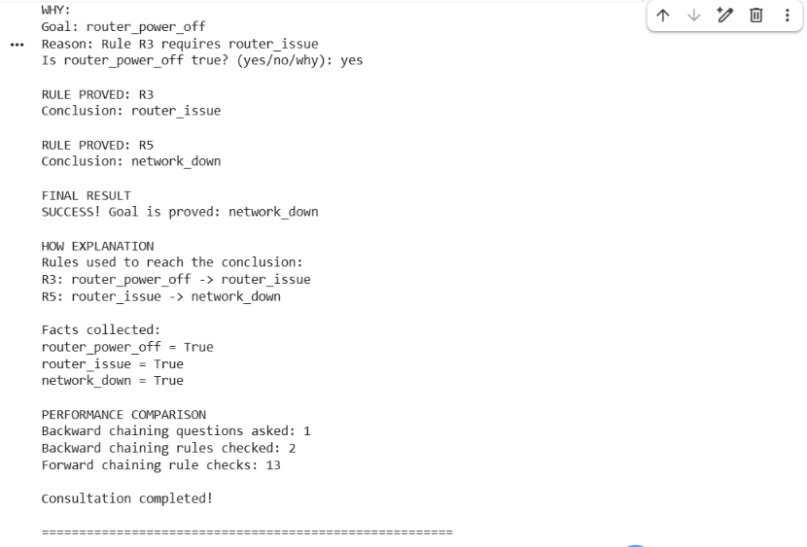
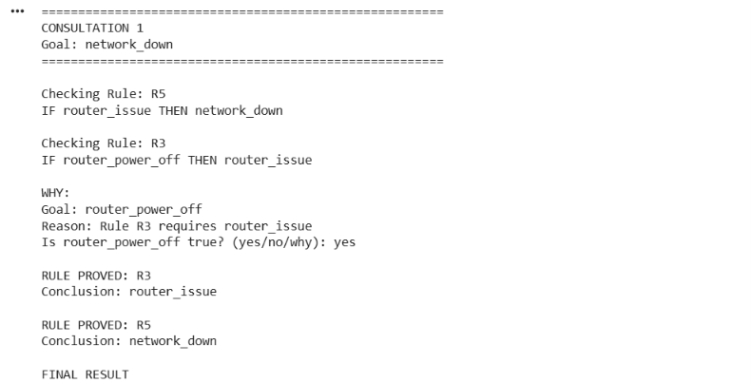

Viva questions:
- Why is backward chaining better for consultation-style diagnosis?
- How does your system avoid asking the same question twice?
- What does the explanation facility add to trust in the system?

Experiment 6: Building and Reasoning over an Ontology
Level: Medium | CO: CO1 | Duration: 3 hours | Marks: 10
Aim: To design a small ontology, create instances, and use a reasoner to check consistency and infer new facts.
Tools: Protégé with the HermiT reasoner, or Python owlready2
Domain: University (Person, Student, Faculty, Course, Department) or Hospital, Library or Retail.
Procedure:
- Write 5 competency questions the ontology must answer (for example: Which courses does Asha attend?)
- Create at least 8 classes with a class hierarchy (Student and Faculty as subclasses of Person)
- Create object properties (enrolledIn, teaches, belongsTo) with domain and range, and data properties (hasName, hasCredits)
- Add restrictions: Student and Faculty are disjoint; a Course must have at least one teacher
- Create at least 10 individuals with their property values
- Run the reasoner. Record the inferred class membership (for example, a person who enrolledIn a course is inferred to be a Student through the domain axiom)
- Deliberately create an inconsistency (a person who is both Student and Faculty) and record what the reasoner reports
- Answer the competency questions with queries (the DL Query tab in Protégé, or SPARQL through rdflib)
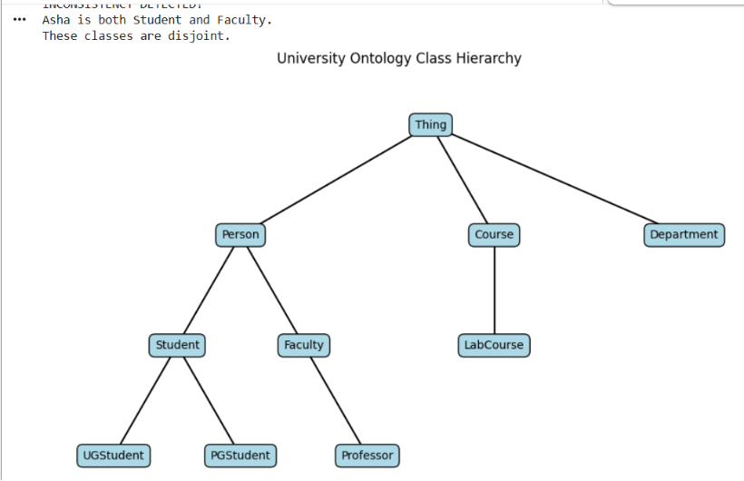
Expected output: The ontology file (.owl), a diagram of the class hierarchy, the list of inferred facts, the inconsistency report and the answers to the competency questions.
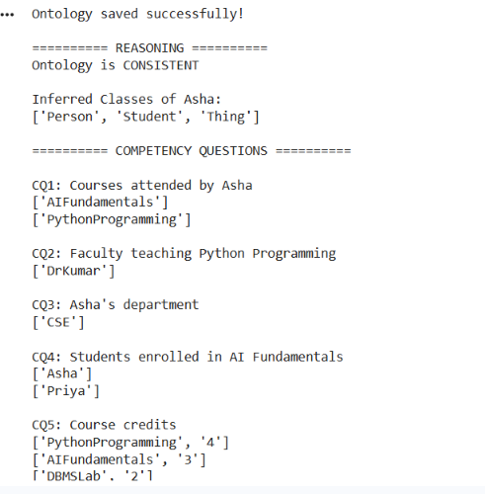

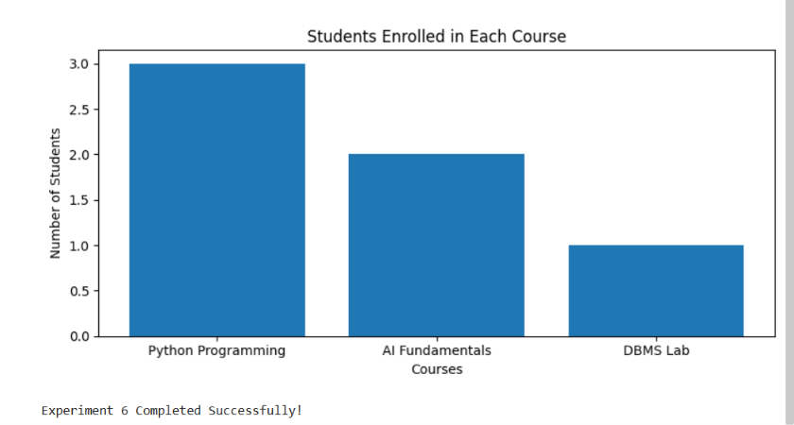

Viva questions:
- How does an ontology differ from a taxonomy and from a database schema?
- What is the difference between a domain and a range?
- Which of your competency questions could not be answered, and why?

Experiment 7: Building and Querying a Knowledge Graph
Level: Medium | CO: CO1 | Duration: 3 hours | Marks: 10
Aim: To construct a knowledge graph from tabular and text data, resolve duplicate entities, and query it.
Tools: Python, pandas, rdflib, networkx
Data: Two CSV files, people.csv (person_id, name, department, city) and works.csv (person_id, project, role), plus 10 sentences of text such as "Asha works on Project Alpha at Anna University". Include two spellings of the same person (for example "A. Kumar" and "Arun Kumar").
Procedure:
- Define a namespace and a small schema (classes Person, Project, Department, City; properties worksOn, memberOf, livesIn)
- Convert each CSV row into RDF triples with rdflib and add them to a graph
- Extract simple triples from the sentences by pattern matching (for example X works on Y) and add them
- Perform entity resolution: detect the duplicate person using a simple rule (same department and similar name, using difflib.SequenceMatcher) and merge them
- Write at least five SPARQL queries, for example: who works on Project Alpha; who is in the same department as Asha; which projects involve people in Chennai
- Convert the graph to networkx, compute the degree of each node and find the most connected entity
- Draw the graph
Expected output: The graph file (Turtle format), query results, the merge decision for the duplicate, and the graph drawing.
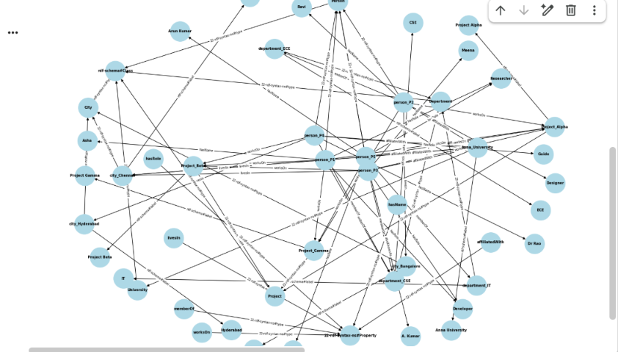

Viva questions:
- What is a triple, and why is a graph more flexible than a table for connected data?
- Why is entity resolution necessary?
- How could an ontology improve this knowledge graph?

Experiment 8: Hypothesis Testing, ANOVA and Chi-Square with Evidence
Level: Medium | CO: CO4 | Duration: 3 hours | Marks: 10
Aim: To test claims about data using t-tests, ANOVA and the chi-square test, and to state conclusions supported by test statistics and p-values.
Tools: Python, scipy.stats, pandas, matplotlib
Data: exam_scores.csv with student, method (three teaching methods A, B, C), score_before, score_after, gender, result (pass or fail) for at least 60 students. The instructor may generate synthetic data so that the methods really differ.
Procedure:
- State the null and alternative hypotheses and the significance level (0.05) before each test
- One-sample t-test (ttest_1samp): is the mean score_after different from the claimed mean of 60?
- Independent-samples t-test (ttest_ind): compare methods A and B
- Paired t-test (ttest_rel): compare score_before and score_after
- One-way ANOVA (f_oneway) across methods A, B and C. If significant, compare the group means and say which methods appear to differ
- Chi-square test of independence (chi2_contingency) between gender and result
- For each test, report the test statistic, p-value, decision and a conclusion in plain words. Add a box plot of scores by method
- Calculate a 95% confidence interval for the mean of score_after
Expected output: A results table (test, hypotheses, statistic, p-value, decision, conclusion), a box plot and the confidence interval.
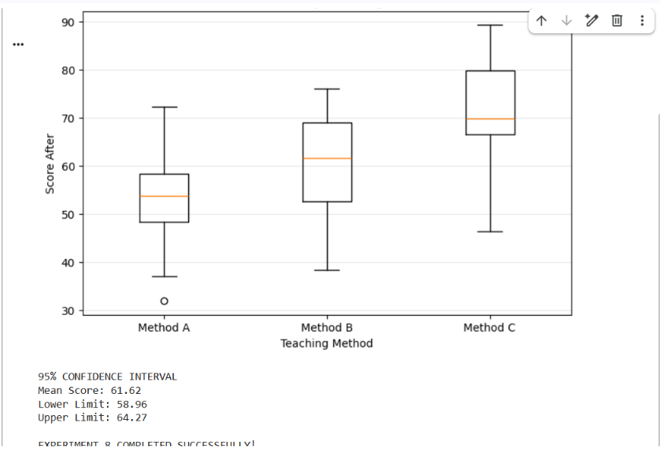
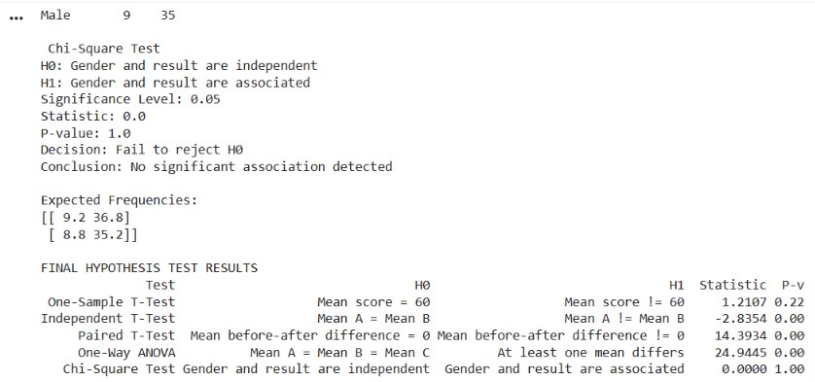

Viva questions:
- What does a p-value of 0.03 mean, and what does it not mean?
- Why use ANOVA instead of several t-tests?
- If the p-value is 0.07, what do you conclude at the 0.05 level, and what would you do next?

PART C – HARD EXPERIMENTS

Experiment 9: Acquiring Rules from Data with Decision Trees
Level: Hard | CO: CO5 | Duration: 4 hours | Marks: 14
Aim: To acquire knowledge automatically from data as IF-THEN rules, evaluate it rigorously, and compare it with hand-written expert rules.
Tools: Python, scikit-learn, pandas, matplotlib
Dataset: Breast Cancer or Wine (both bundled with scikit-learn), or a dataset given by the instructor. (Use for learning only. Not for clinical use.)
Procedure:
- Split the data into training and test sets (70:30, with a fixed random seed and stratification)
- Write a baseline: always predict the majority class. Record its accuracy
- Write expert-style rules by hand (at least 4 rules) from the feature descriptions and a look at the training data. Evaluate them on the test set
- Train a DecisionTreeClassifier with depth limits of 2, 3, 4 and 6. For each depth record training accuracy, test accuracy and 5-fold cross-validation accuracy. Plot accuracy against depth and identify overfitting
- Choose a depth with evidence, then use export_text to print the tree. Convert the tree into IF-THEN rules and count the rules and conditions
- Compute a confusion matrix, precision, recall and F1-score for the tree and for your expert rules
- Write a short critique: which is better, and in which sense (accuracy, rule count, readability, risk of missed positives)? Which rules would a domain expert accept or reject?
Expected output: A comparison table (baseline, expert rules, trees of each depth), the accuracy-versus-depth plot, the final rule list in readable form and a written critique of 150 to 200 words.
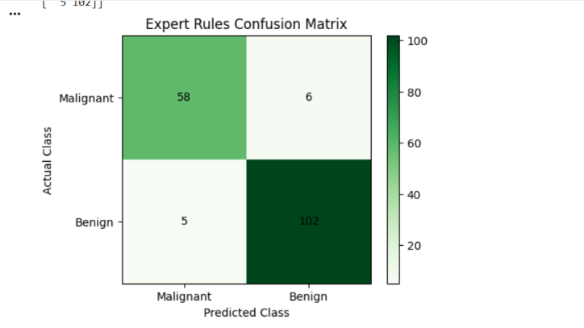
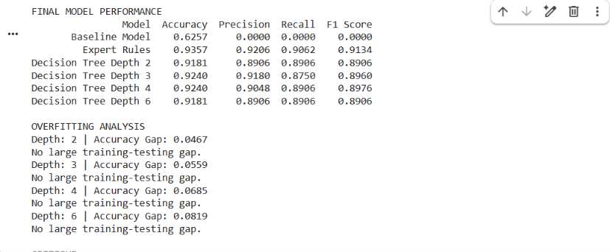

Viva questions:
- Why can a very deep tree have 100% training accuracy but poor test accuracy?
- Why is accuracy alone misleading on imbalanced data?
- How would you present the learned rules to a domain expert for validation?
- What are the advantages of learned rules over hand-written rules, and the risks?

Experiment 10: Hybrid Decision-Support System (Knowledge Graph, Rules and Machine Learning)
Level: Hard | CO: CO1, CO2, CO5 | Duration: 6 hours (mini-project, may run over two sessions) | Marks: 14
Aim: To design, build and evaluate a decision-support system that combines a knowledge graph, an expert rule base and a machine learning model, and that explains its recommendations.
Tools: Python, pandas, rdflib or networkx, scikit-learn
Choose one scenario (or propose your own with the instructor's approval):
- Course recommender: suggest elective courses to students
- Crop advisor: recommend crops and warn about diseases from soil, season and symptoms
- IT help-desk assistant: route and diagnose faults
- Fitness or nutrition planner: advise on activity levels and goals (educational use only)
Requirements:
- Knowledge graph: at least 40 triples with a simple schema describing the domain entities and relationships
- Rule base: at least 10 expert rules with certainty factors, using forward or backward chaining, including at least one rule with evidence against a conclusion
- Machine learning model: a classifier or recommender trained on a dataset of at least 100 records (real or synthetic). Report cross-validated performance
- Combination logic: define clearly how the three parts work together, for example the graph supplies facts to the rules, the rules produce candidate answers with certainties, and the model gives a second opinion. State what happens when they disagree
- Explanation: for each recommendation, print the facts used, the rules fired and the model's confidence
- Evaluation: test on at least 20 cases and compare four systems: rules alone, model alone, the hybrid, and a simple baseline. Report accuracy and at least one other measure. Include at least one failure case and analyse why it failed
- Limitations and ethics: state what the system must not be used for and what additional data or expert review would be needed before real use
Deliverables: Source code, data files, a system diagram, a results table, 5 sample explanations and a 4 to 5 page report with evidence-based conclusions.
Evaluation criteria:
Criterion | Marks
Design and combination logic | 3
Working implementation | 4
Evaluation with evidence and failure analysis | 4
Report and ethics discussion | 1
Viva | 2
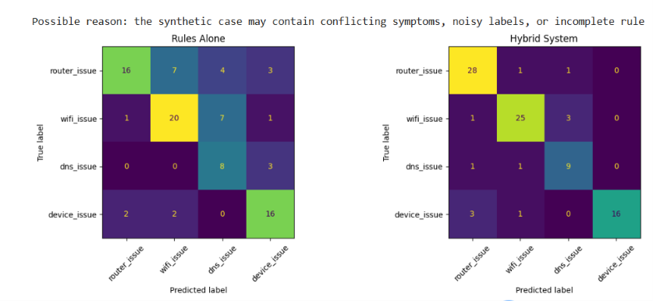
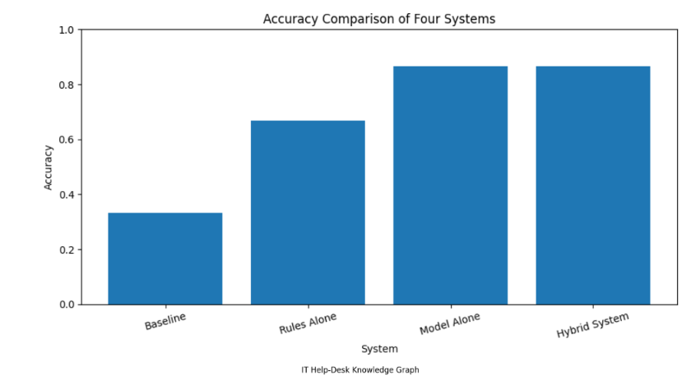

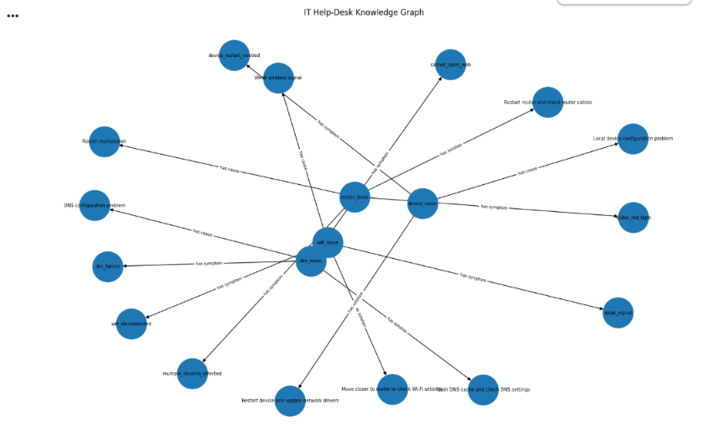

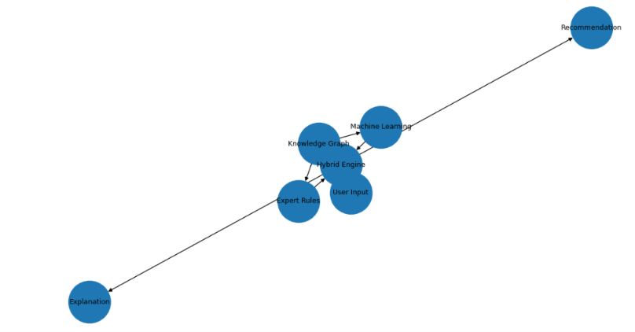

Viva questions:
- Why combine rules with machine learning instead of using either alone?
- What did the hybrid improve over each single part, and what evidence shows it?
- How do you resolve a disagreement between the rules and the model?
- What would you need to do before this system could be trusted in practice?

2. Common Rubric for Evidence-Based Work
Criterion | Excellent | Satisfactory | Needs improvement
Prediction and method | Clear plan and predictions before running | Method given, few predictions | No plan
Correctness | Code and results correct and reproducible | Minor errors | Major errors
Evidence and analysis | Every claim supported by numbers or output | Some claims supported | Unsupported statements
Critical thinking | Limits, failures and alternatives discussed | Brief discussion | None
Presentation | Clean code, labelled charts and tables | Readable | Hard to follow

3. Suggested Schedule (14-Week Semester)
Week | Experiment
1 | Setup and Experiment 1
2 | Experiment 2
3 | Experiment 3
4 | Experiment 4
5 | Revision and lab test on Part A
6 to 7 | Experiment 5
8 | Experiment 6
9 | Experiment 7
10 | Experiment 8
11 | Experiment 9
12 to 13 | Experiment 10 (mini-project)
14 | Viva and model practical examination

